**CANCER INFORMATION MODULE**

*ABRSTRACT:*

*The following document proposes a design of a cancer symptom module for the people who find difficult to browse through the internet as well as for the visually challenged. It requires a little effort from the user to touch the screen where they find it more reliable to their affected body part. The user will be responded by the system in a voice in accordance to the body part where they have touched and proceed further inside the module.*

*keywords: cancer symptom module.*

*voice commands.*

*ulk kit.*

Introduction

Surfing across the web is an simple task, but when it comes for people those who are not much good at surfing this module helps them in ease their work load. On simply touching on to the screen the user will be fed with the required information they need and if the user finds it difficult to read a voice will be generated which will be reading the paragraph out.

Methodology

The module will be having a touch, clcd and a glcd, iwhere on touching, a related picture pops up on the screen and in the clcd displays the description of the picture that is displayed. Further moving inside the module on touching, the glcd and the clcd will work parallelly and display.

the picture and the description of the other pictures. In special case touching the picture will also play an audio which will read out the name and the description of the picture.

The working flow chart of the design is as follows,

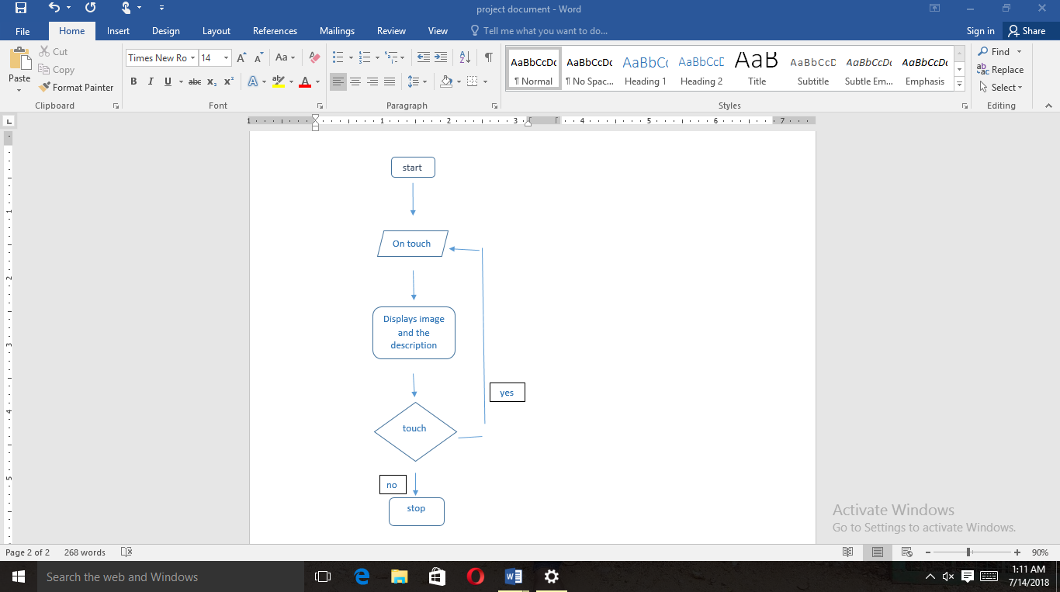

ARCHITECTURE

The GLCD commands are used to control a Graphical Liquid Crystal Display based on the number of GLCD chip sets. These are often 128*64 pixel displays but the size can vary. GLCD devices draw graphical elements by enabling and disabling the pixels.

The Character lcds are ideal for displaying text. These modules are preferred over 7segments and other multisegment leds.

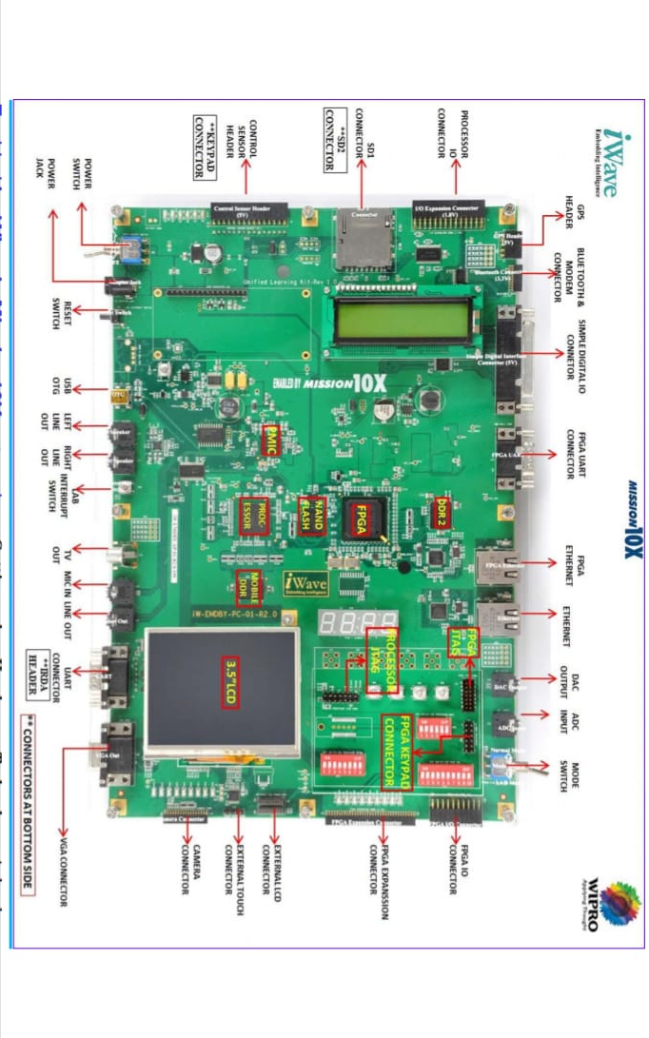

FEATURES

This module will consist of voice commands which will speak out the info which will be displayed on the screen. This will help the user to understand what it is whether the user knows to read or not.

CONCLUSION

Thus in the end this module will provide a lot of info about the diseases in simple steps.